**Bad Special Roles:**

Assassin: Deadshot (suicide squad)

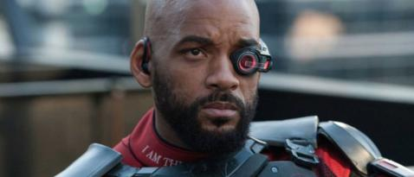

Oberon: Will Smith on Youtube

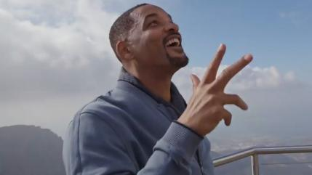

Mordred: Will Smith Genie

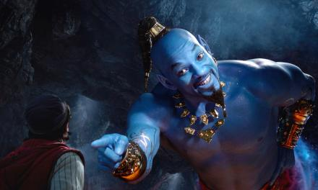

Morgana: Hancock

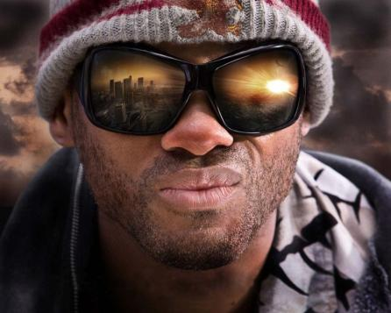

Random Bads:

Get Jiggy Pharaoh -

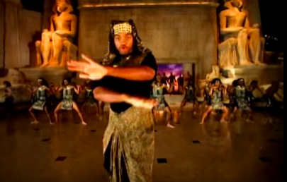

Gemini (Weird CGI)

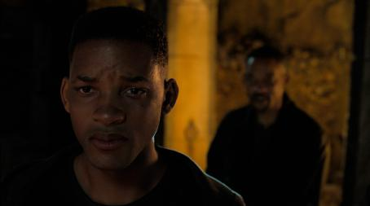

After Earth

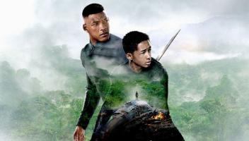

Shark Tale Character

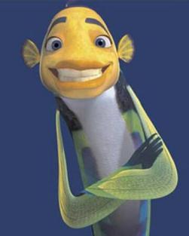

**Good Special Roles:**

Merlin: Fresh Prince Will

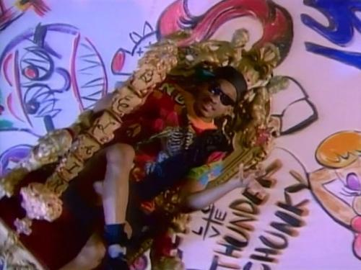

Percival: Miami Will (pink shirt)

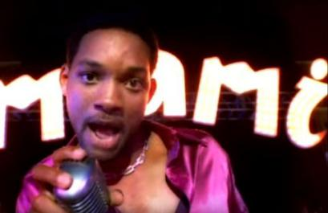

**Random Goods:**

The bird from his new movie

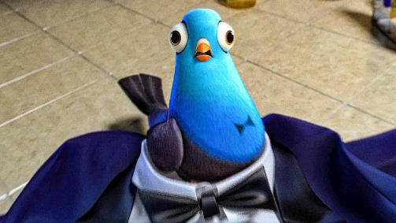

Dr. Hitchens (Hitch)

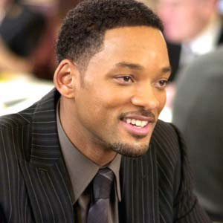

“Oh Wow.” shirtless will from I, Robot -

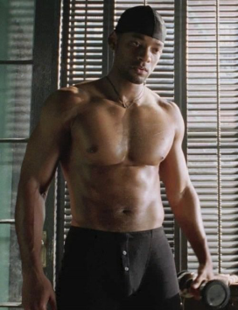

Independence Day Will

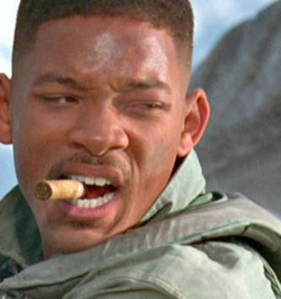

Jim West (Wild Wild West)

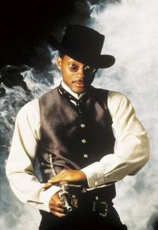

Agent J (MIB)

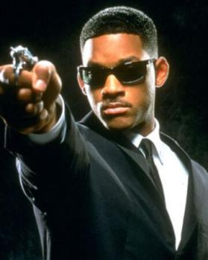

I am Legend

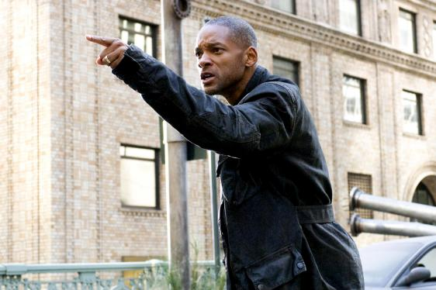

Ali (Ali)

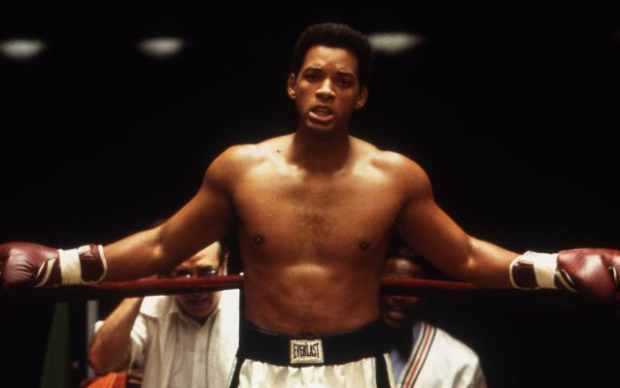

**Only For First Round:**

The Party Starter (song)

